

**Hydrostatic Pressure**

|  |  |
| --- | --- |
| Name | Student ID |
| Divya Yazhini David | 1607029398 |
| Wadad Ghorab | 1604028696 |
| Batoul Daou | 1707030876 |

Professor: Sherin Amir

Course: EMEC 330

Table of Contents

**Objectives3**

**Theoretical Background3**

**Materials and Procedures5**

**Data and Data Analysis8**

**Error Analysis9**

**Conclusion10**

**Work Distribution11**

**References11**

**Figure 1: Materials 5**

**Table 1.1: Percentage Error 9**

1. **Objectives**

The objective of this experiment is to measure the hydrostatic force acting on vertical plane that is partially and fully submerged in water. As well as, measuring the hydrostatic force on a tilted plane, at an angle, that is partially and fully submerged in water.

1. **Theoretical Background:**

Our experiment’s objective was to find the resultant force by the water onto the gate using the hydrostatic pressure apparatus. The purpose of the apparatus is to measure the moment created by the fluid on a fully or partially submerged plane surface. [1] The resultant force was found for four different conditions: fully submerged vertical plane, partially submerged vertical plane, fully submerged inclined plane, and partially submerged inclined plane. In this experiment the fluid is at rest, therefore, the force is normal to the surface and if the fluid is incompressible, the pressure will vary linearly. For every condition used we first calculated the resultant force theoretically in order to compare it with the experimental data. $Fr= γ*hc*A$  
 (1)

Fr (Theoretical): Resultant force of the fluid on the surface.

γ : Specific weight of the fluid.

hc: Height of the surface of water to centroid of the gate.

A: Area of the submerged gate.

* For experimental data:

To obtain the experimental hydrostatic force, moment around the hinge O of the apparatus was taken. For equilibrium, the moment around O has to be zero.

$Fg*L=Fr*Id$ (2)

Fg (N): The force of the added weights to balance the added fluid.

L (m): Length of the lever arm.

Fr: Experimental resultant force.

Id: Distance from hinge until the point where the resultant hydrostatic force acts.

To find Id, length of the lever arm, we use the following equation:

$yr=\frac{Ixc}{yc.A}+yc$ (3)

yr: Distance from water surface level to the resultant force on the gate.

Ixc: Second moment of the area passing through centroid and parallel to the x-axis.

Yc: Distance from surface of water to centroid of gate. (equal to hc in vertical planes)

In this experiment we use this equation to find Ixc however it varies for different gates:

$Ixc= \frac{bh^{3}}{12}$ (4)

Then when yr is found, we use the equation below to find Id to put in equation 2 to find Fr:

$Id=L-(hw-yr)$ (5)

L: Total distance from hinge to bottom of gate.

hw: Height of surface of the water to the bottom of the gate.

In order to find the error between experimental and theoretical data we use:

$error\left(\%\right): \frac{Fr\exp{- Fr theor}}{Fr theor}×100$ (6)

1. **Materials and Procedures:**

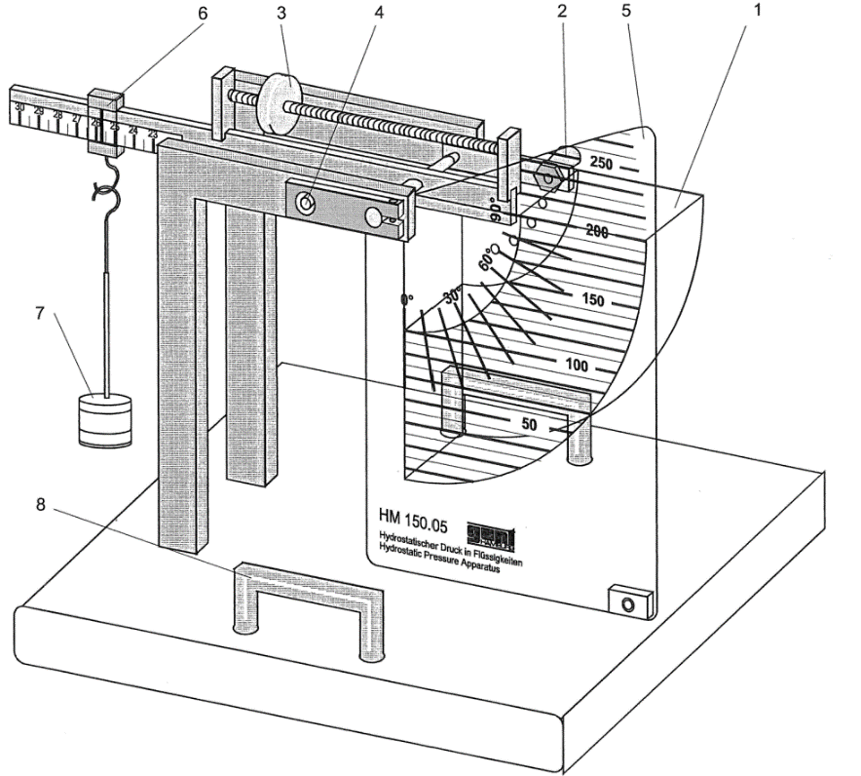

Figure : Materials

*Materials used in this experiment:*

1. Water Vessel
2. Detent
3. Slider
4. Stop pin
5. Water level scale
6. Rider
7. Weights
8. Handles

*Procedures for different conditions:*

* For condition **1** (water depth < 10cm and angle = 0):

Step 1) Balance the whole system, without any extra weights attached, by adjusting the slider.

Step 2) Fill in the water vessel with water until your desired height which should be less than 10 cm. In our case, we filled it up to 60mm.

Step 3) Balance the system with weights and by adjusting the slider.

Step 4) Record the appended weights of the system after balancing. Then record the lever arm by using the rider.

Step 5) After recording, remove all the weights and use the handle to get rid of the water in the vessel.

* For condition **2** (water depth > 10cm and angle = 0):

Step 1) Balance the whole system, without any extra weights attached, by adjusting the slider.

Step 2) Fill in the water vessel with water until your desired height which should be more than 10 cm. In our case, we filled it up to 150mm.

Step 3) Balance the system with weights and by adjusting the slider.

Step 4) Record the appended weights of the system after balancing. Then record the lever arm by using the rider.

Step 5) After recording, remove all the weights and use the handle to get rid of the water in the vessel.

* For condition **3** (water depth < 10cm and angle ≠ 0):

Step 1) Tilt the water vessel to your desired angle by using the detent. In our case, we tilted it till 20◦. Reminder: by titling the vessel, your horizontal reference is not zero anymore. Therefore, our horizontal reference (lowest water level) is 12mm.

Step 2) Balance the whole system, without any extra weights attached, by adjusting the slider.

Step 3) Fill in the water vessel with water until your desired height which should be less than 10 cm. In our case, we filled it up to 96mm.

Step 4) Balance the system with weights and by adjusting the slider.

Step 5) Record the appended weights of the system after balancing. Then record the lever arm by using the rider. Reminder: while recording the water level reading, it is equal to the difference between the highest water level and the lowest water level.

Step 6) After recording, remove all the weights and use the handle to get rid of the water in the vessel.

* For condition **4** (water depth > 10cm and angle ≠ 0):

Step 1) Tilt the water vessel to your desired angle by using the detent. In our case, we tilted it till 20◦. Reminder: by titling the vessel, your horizontal reference is not zero anymore. Therefore, our horizontal reference (lowest water level) is 12mm.

Step 2) Balance the whole system, without any extra weights attached, by adjusting the slider.

Step 3) Fill in the water vessel with water until your desired height which should be more than 10 cm. In our case, we filled it up to 140mm.

Step 4) Balance the system with weights and by adjusting the slider.

Step 6) Record the appended weights of the system after balancing. Then record the lever arm by using the rider. Reminder: while recording the water level reading, it is equal to the difference between the highest water level and the lowest water level.

Step 6) After recording, remove all the weights and use the handle to get rid of the water in the vessel.

1. **Data and Data Analysis:**

Refer to “data sheet and calculations” for collected data attached at the end of the report.

For angle α=0:

When the fluid level is increased, the more weights we add in order to balance the whole fluid system. When we calculated the lever arm, Id, we get a higher resultant force when the distance is less. This is due to the moment in equation 2.

For angle α≠0:

The same thing occurs as angle equal to zero however the resultant force increases by a lesser amount than when the plane is vertical. The Fr for inclined increased by 4.382N whereas Fr for the vertical plane increased by 8.32N which is almost double.

[BATOUL PLEASE REVISE AND ADD MORE DETAIL IF U WANT]

1. **Error Analysis:**

Table 1.1, below shows the percentage error for each condition

Table .1: Percentage Error

|  |  |  |  |
| --- | --- | --- | --- |
| Condition | Hydrostatic force (theoretical) | Hydrostatic force  (Experimental) | Percentage error (%) |
| Condition 1:  Vertical plane (Partially Submerged) | 1.32 N | 1.56 N | 18.18 % |
| Condition 2:  Vertical Plane  (Fully Submerged) | 7.35 N | 7.28 N | 0.95 % |
| Condition 3:  Tilted Plane  (Partially Submerged) | 2.76 N | 2.39 N | 13.41 % |
| Condition 4:  Tilted Plane  (Fully Submerged) | 5.96 N | 6.76 N | 13.42 % |

In reference to table 1.1, the percentage error was on average less than 30%, thus showing an acceptable run for the experiment and good results. However, these percentage error can be accounted for by the sources of error.

One of the sources of error, was the human error. In the beginning of the experiment it is needed to balance the apparatus out by manipulating the weights until the bubble was in the middle. However, the bubble was never exactly in the middle, this could affect the length of the lever arm or the weights needed to balance it out. While adding water it was also done by human eye and even though there were divisions of 5 mm on the apparatus the divisions were not small. This could have affected our measure to the height of the water as if there was little water at higher level than the division it was approximated down. This could explain the error of 18.18% in condition 1.

Another source of error was the weights. The weights added had specific range and to balance the system instead of adding small weights multiple times, a specific weight was added, and the slider needed to be moved to balance the system. Adjusting the slider was a problem because it could not be exactly in the middle.

1. **Conclusion:**

After finding the resultant force of the water on the surface tested in four conditions, it was noticed that in all cases: when the water level increases, the resultant force increases. This is due to the moment created when more fluid is added making Id (the calculated lever arm) less, causing an increase in force. On the other hand, the difference between vertical planes and inclined planes was the increase in resultant force when the surface is partially and fully submerged. In the vertical planes this difference was larger than the difference found in inclined planes. There was an error percentage range of 0-20% however this may be due to human error and experimental error.

1. **Work Distribution:**

Divya Yazhini David: Format and Presentation; Materials and Procedures;

Wadad Ghorab: Theoretical Background; Conclusion;

Batoul Daou: Objective; Error Analysis;

Data and Data Analysis: divided equally between team members

1. **References:**

[1]: <http://www.echoscaninc.com/new/hydrostatic-pressure>

[2]: B.R. Munson, D.F. Young, T.H. Okiishi, W.W. Huebsch, Fundamentals of Fluid Mechanics Wiley; 7th edition, 2012, ISBN 13: 9781118116135

[3]: Lab Handout for the hydrostatic experiment